Name:___________________________________ Worksheet 8.4R
Period:_____________ Geometry

Decide whether the statement is sometimes, always, or never true.
- A rectangle is a parallelogram.
- A parallelogram is a rhombus.
- A rectangle is a rhombus.
- A square is a rectangle.

Which of the following quadrilaterals have the given property? Note: There may be more than one answer.
5. All sides are congruent. A. Parallelogram
6. All angles are congruent. B. Rectangle
7. The diagonals are congruent. C. Rhombus
8. Opposite angles are congruent. D. Square

For any rectangle ABCD, decide whether the statement is always, sometimes, or never true. Draw a diagram!
9. $∠A≅∠B$
10. $\overline{AB}≅\overline{BC}$
11. $\overline{AC}≅\overline{BD}$
12. $\overline{AC}⊥\overline{BD}$

For any rhombus ABCD, decide whether the statement is always, sometimes, or never true. Draw a diagram!
13. $∠A≅∠C$
14. $∠A≅∠B$
15. $∠ABD≅∠CBD$
16. $\overline{AB}≅\overline{BC}$
17. $\overline{AC}≅\overline{BD}$
18. $\overline{AD}≅\overline{CD}$

List each quadrilateral for which the statement is true (i.e. parallelogram, rectangle, rhombus, and/or square).
19. It is equiangular.
20. It is equiangular and equilateral.
21. The diagonals are perpendicular.
22. Opposite sides are congruent.
23. The diagonals bisect each other.
24. The diagonals bisect opposite sides.

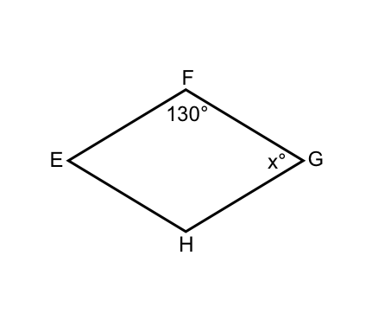
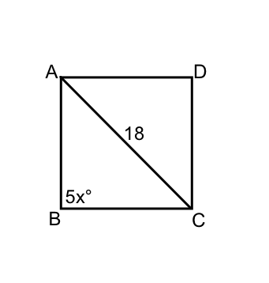
Find the value of x.
25. ABCD is a square. 26. EFGH is a rhombus.

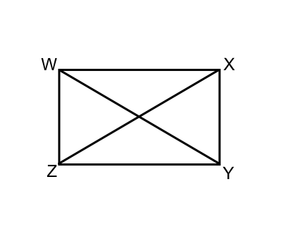

27. WZYZ is a rectangle. The perimeter of $∆XYZ$ is 24. $XY+YZ=5x-1$ and $XZ=13-x$. Find WY.

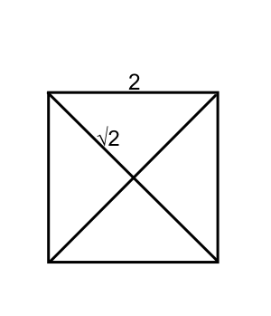

GHJK is a square with diagonals intersecting at L. Given that GH=2 and $GL=\sqrt{2}$, complete the statement.
28. HK=________

29. $m∠KLJ=$____________

30. $m∠HJG=$____________

31. Perimeter of $∆HJK=$___________

